National Lutheran School Accreditation
Cumulative Annual Report
Revised September 2022

<INSERT SCHOOL NAME>
<INSERT CITY, STATE>

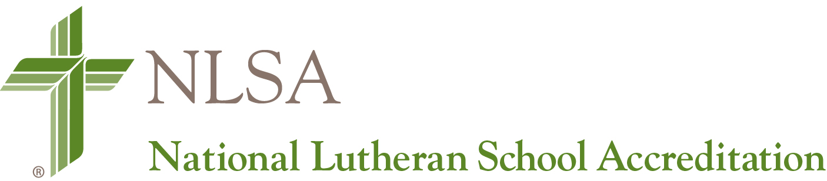
PART I: SCHOOL INFORMATION

School Name:
Address:
City / State / ZIP:

School Administrator Name:
School Administrator Phone Number:
School Administrator Email Address:

LCMS District:

Co-Accredited By (If Applicable):

Cognia
WASC
Middle States
CCLE

Date of Most Recent NLSA Site Visit:

Report is for Year (Indicate One):

Year One
Year Two
Year Three
Year Four
Year Five

Administrator Signature: ______________________________________ Date: _____________

Governing Authority Signature: _________________________________ Date: _____________

This report is due in your district office no later than May 15. The District Accreditation Committee will review by June 15 and submit any findings to the National Accreditation Commission in July.

PART II: RECOMMENDATION REPORT
FOR INDICATORS:

- List Any Major Deficiencies First
- List all Recommendations Made by the Validation Team and Target School Year to be Addressed
- List and Date Actions Taken During this School Year as well as Actions Taken in Previous Years of Accreditation Cycle

NOTE: Please be as specific as possible when completing the following table and include detailed information related to each recommendation and any corrective action taken.

Standard & Indicator Number | Self-Study Concerns and Validation Team Recommendations | Target School Year | Responsible Party | Action Taken | School Year Addressed

NOTE: To add lines to the table for more concerns and recommendations, put the cursor in the bottom right field and type the “tab” key.

