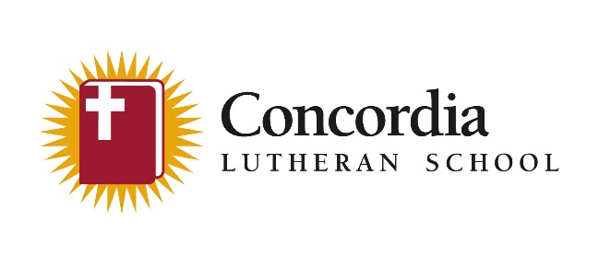

Concordia Lutheran School provides families with a Christ-centered, academically challenging education to equip students for lifelong Christian discipleship and serves as a witness for Christ to our community and world.

Coronavirus Action Plan March, 2020

Current Actions:
- Notify stakeholders regarding the current status of the coronavirus and actions being taking by the faculty and staff of Concordia Lutheran School.
- All homeroom teachers are to review proper handwashing with students.
- Faculty and Staff are to provide frequent opportunities for students to wash their hands and monitor this through age appropriate procedures.
- Custodians are to make cleaning the following touchpoints a high priority:
  - Door handles, crash bars, doorknobs
  - Handrails
  - Sinks and drinking fountains
  - All surfaces that are frequently touched by multiple people
- Faculty and Staff are to make cleaning the following touchpoints a high priority:
  - Telephones
  - Desks, chairs, tables, lockers
  - Computer keyboards, mouse pads
  - Playground equipment
  - Anything else that is handled frequently by multiple people.
- All classrooms are to be supplied with antibacterial wipes and Kleenex.
- Students exhibiting symptoms of illness will be placed in the “sick room” until they are picked up by a parent/guarding or designated person.
- Individuals are not to return to school and school activities for at least 24 hours after their fever is gone. Fever should be gone without the use of a fever-reducing medicine. A fever is defined as 100°F (37.8°C) or higher.
- Administration may require that a student, staff or faculty member be removed from school or school activities if administration deems that a student, staff or faculty poses a health risks to others.

Future Actions To Be Implemented As Appropriate:
- Notify stakeholders regarding changes in the status of the coronavirus and actions being taking by the faculty and staff of Concordia Lutheran School.
- When possible increase space between people at school to at least 3 feet.
- If an excessive number of students are absent Concordia may close for a specified period of time.

The administration of Concordia will continue to monitor CDC and other originations for updates regarding health concerns.

As we look forward to Spring Vacation (3.23.2020-3.27.2020), it should be noted that travel is identified as a potential catalyst for the spread of the coronavirus. With this we are asking that all our families commit to helping keep our school community safe and healthy. If a student, staff or faculty member are feeling ill, have been in close contact with someone who is ill, or have travelled to an area under a CDC Travel Notice please remain at home and notify the school office.

